PROJECT DESIGN PHASE –II

DATA FLOW DIAGRAM AND USER STORIES

|  |  |
| --- | --- |
| DATE | 1 NOVEMBER 2022 |
| TEAM ID | PNT2022TMID51449 |
| PROJECT NAME | IoT Based Safety Gadget for Child Safety Monitoring & Notification |
| MARKS | 4 MARK |

DATAFLOW DIAGRAM:

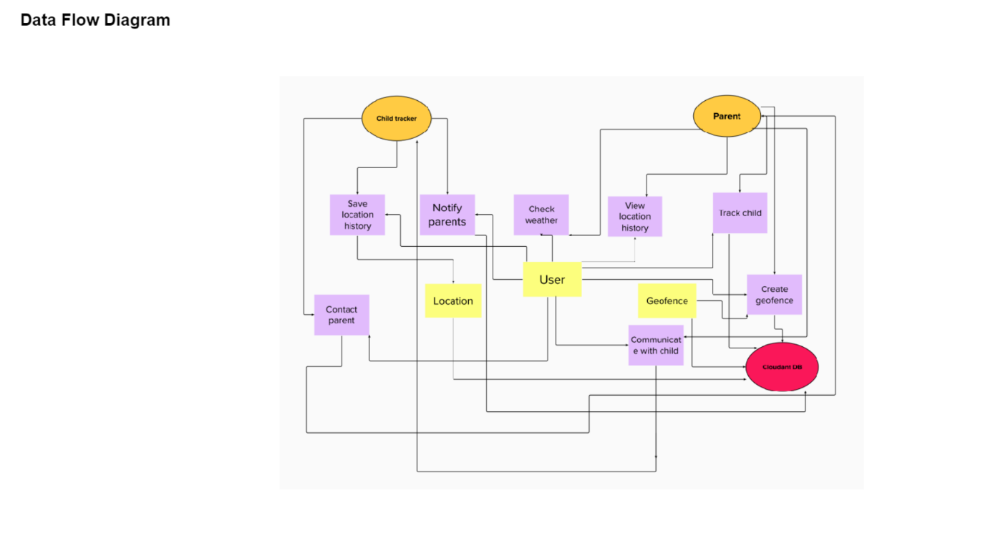USER STORIES:

